JIRA REPORTING BUGS PROJECT

<https://tomicsalad.atlassian.net/jira/software/c/projects/DEMO/issues/?filter=reportedbyme>

DEMO SHOP WEBSITE TESTING PRESENATTION !!!

Titlul proiectului : TESTAREA FUNCTIONALITATILOR APLICATIEI DEMO SHOP website

Scopul proiectului : Generarea unei suite de test caseuri pentru testarea , verificarea functionalitatilor de baza ale aplicatiei de e-commerce DEMO SHOP . Aceste functionalitati sunt precum cele de LOGIN , LOGOUT , PRODUCTS PRESENTATION PAGE , MY CART , MY WISHLIST , SEARCH PRODUCT , SORT PRODUCT

Procesul testarii se desfasoara in felul urmator

1 Primim APLICATIA e-commerce DEMO SHOP in varianta gata de testare

2 Executam EXPLORATORY TESTING pentru a cunoaste functionalitatile principale si modulele aplicatiei software

3 Executam SMOKE testing pentru a testa functionalitatile de baza ale aplicatiei

4 Impartim aplicatia pe module pentru a efectua COMPONENT MODULE testing

5 Metoda de testare este functional testing (testam functionalitatile aplicatiei) , executam testarea cu tehnica BLACK BOX adica identificam datele de input si urmarim datele de output pe care le obtinem fara ca sa fim interesati de mecanismele interne ale aplicatiei DEMO SHOP

6 Efectuam INTEGRATION TESTING unde efectuam teste care imiplica intr-un process de test mai multe module combinat

7 In incheiere efectuam SYSTEM testing , END-TO-END test unde executam teste care implica un process intreg de utilizare a aplicatie si implica toate modulele ce iau parte in procesul testarii.

Bug ID : PDP-1 (Products presentation Page)

Bug Title/Summary : Different product types have exact the same characteristics description text

Bug DETAILS :

Type : BUG

Status : New

Priority : High

Severity : Medium

Environment : Device LAPTOP ; OS WINDOWS ; Browser Google CHROME ; Website <https://fasttrackit-test.netlify.app/#/> ; Version [Demo Shop | build date 2021-05-21 14:04:30 GTBDT](https://fasttrackit-test.netlify.app/) ; Component “Products” presentation page

Bug Description : At “Products” presentation page different product category , type products have exact the same product characteristics description text , documentation.

Bug Steps to Reproduce :

1. Open <https://fasttrackit-test.netlify.app/#/> application website

2. Click “Awesome Soft Shirt” product name link

3. Read “Awesome Soft Shirt” description text

4. Click green bag symbol

5. Click “Gorgeous Soft Pizza” product name link

6. Read “Gorgeous Soft Pizza” description text

7. Compare “Awesome Soft Shirt” and “Gorgeous Soft Pizza” description text

Expected Results : “Awesome Soft Shirt” and “Gorgeous Soft Pizza” product description text should be different from each other and should describe the correspondent product characteristics

Actual Results : “Awesome Soft Shirt” and “Gorgeous Soft Pizza” product have the same product characteristics description text

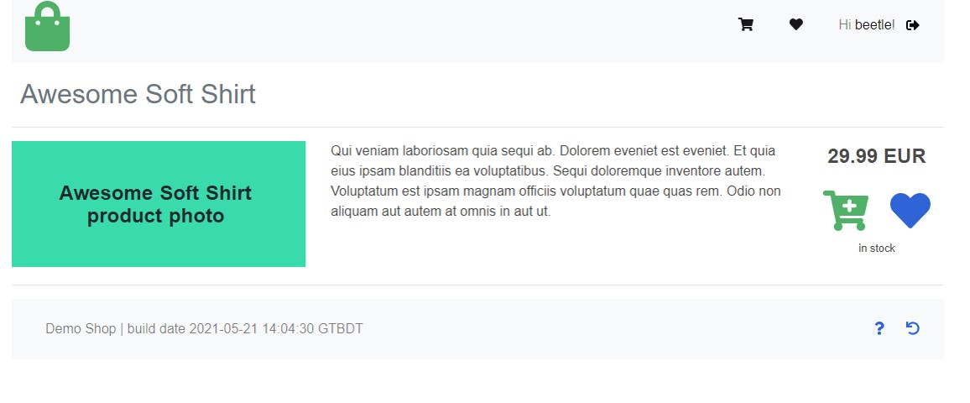

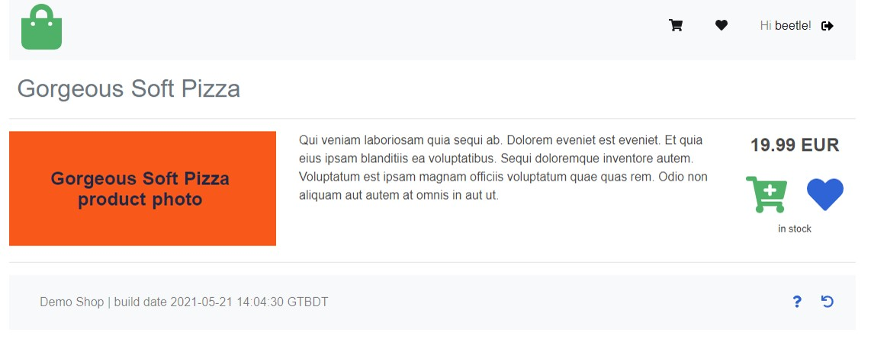

Bug ID : YC-1 (Your cart page)

Bug Title/Summary : Add to cart function of product displayed on “Products” page not performing

Bug DETAILS :

Type : BUG

Status : New

Priority : High

Severity : High

Environment : Device LAPTOP ; OS WINDOWS ; Browser Google CHROME ; Website <https://fasttrackit-test.netlify.app/#/> ; Version [Demo Shop | build date 2021-05-21 14:04:30 GTBDT](https://fasttrackit-test.netlify.app/) ; Component My Cart

Bug Description : After click on the green cart symbol of “Awesome Granite Chips” ,”Awesome Metal Chair”, “Awesome Soft Shirt”, “Gorgeous Soft Pizza”, “Practical Metal Mouse” on “Products” page the black cart symbol does not count the mentioned products as being added to “Your cart” section and not appear as added in “Your cart” page

Bug reproduction data : username : beetle ; password : choochoo

Bug steps to reproduce :

1. Open <https://fasttrackit-test.netlify.app/#/> application website

2. Click black arrow ->] symbol   
  
3. Type in valid username and password   
  
4. Click on blue Login button   
  
5. Click "Awesome Metal Chair" product green cart symbol   
  
6. Click "Awesome Soft Shirt" product green cart symbol

7. Click "Awesome Granite Chips" product green cart symbol

8. Click "Gorgeous Soft Pizza" product green cart symbol

9. Click “Practical Metal Mouse” product green cart symbol  
  
10. Verify if black cart symbol count five products added to cart

11. Click on black cart symbol

12. Verify if related five products are added to the “Your cart” page

Expected results : The black cart symbol count five products added to cart . “Awesome Metal Chair" product, "Awesome Soft Shirt" product, "Awesome Granite Chips" product, "Gorgeous Soft Pizza", “Practical Metal Mouse” product appear being added to the “Your cart” page

Actual results : The black cart symbol does not count any products and the products do not appear being added to “Your cart” page . The “Your cart” page is empty and show “How about adding some products in your cart?” message

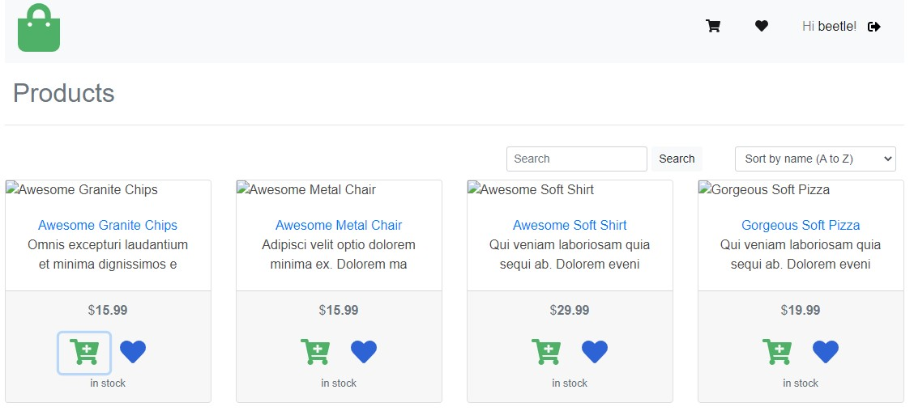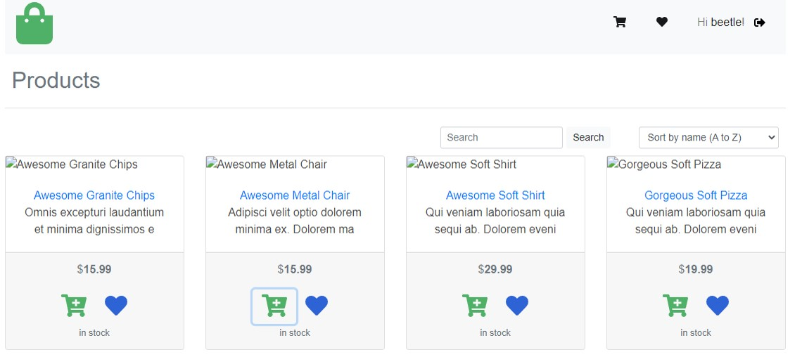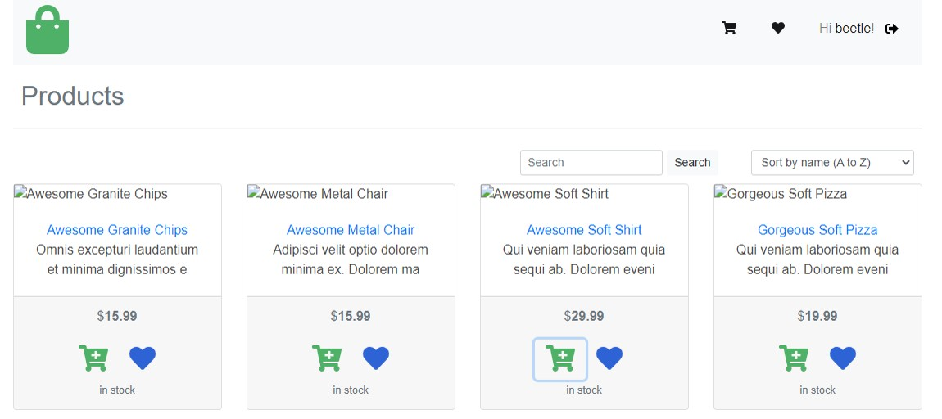

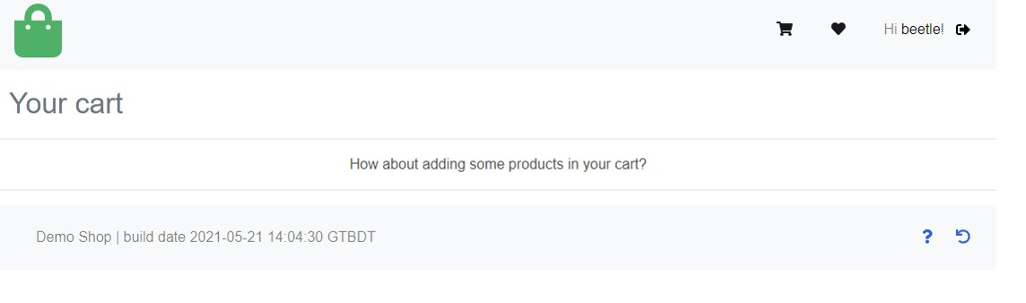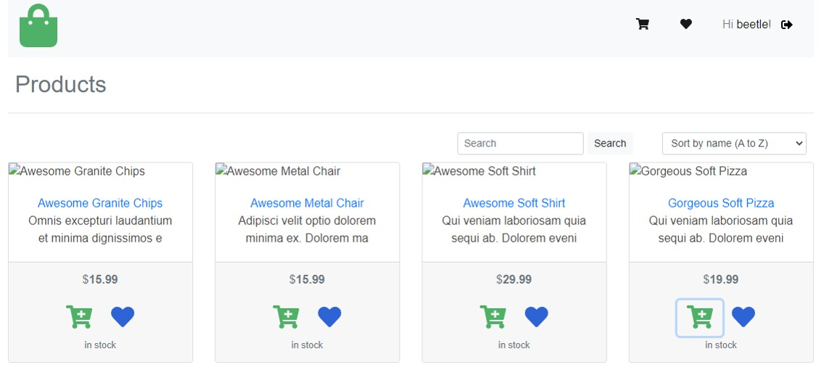

Bug ID : YC-2 (Your cart page)

Bug Title/Summary : Add to cart function of previously searched product not performing

Bug DETAILS :

Type : BUG

Status : New

Priority : High

Severity : High

Environment : Device LAPTOP ; OS WINDOWS ; Browser Google CHROME ; Website <https://fasttrackit-test.netlify.app/#/> ; Version [Demo Shop | build date 2021-05-21 14:04:30 GTBDT](https://fasttrackit-test.netlify.app/) ; Component My Cart

Bug Description : After products are first being searched and the searched products green cart symbol is clicked the black cart symbol does not count the mentioned products as being added to “Your cart” section and not appear as added in “Your cart” page

Bug reproduction data : username : beetle ; password : choochoo

Bug steps to reproduce :

1. Open <https://fasttrackit-test.netlify.app/#/> application website

2. Click black arrow ->] symbol   
  
3. Type in valid username and password   
  
4. Click on blue Login button

5. Type “Awesome” in search field

6. Click “Search” button

7. Click “Awesome Granite Chips” product green cart symbol

8. Click “Awesome Metal Chair” product green cart symbol

9. Click “Awesome Soft Shirt” product green cart symbol

10. Verify if black cart symbol count three products added to cart

11. Type “Gorgeous” in search field

12. Click “Search” button

13. Click “Gorgeous Soft Pizza” product green cart symbol

14. Verify if black cart symbol count four products added to cart

15. Click on black cart symbol

16. Verify if mentioned searched four products are added to the “Your cart” page

Expected results : After click on the searched products green cart symbol the black cart symbol should count the number of products added to cart and products should appear in “Your cart” page as being added to cart.

Actual results : After click on first searched products green cart symbol the black cart symbol does not count any products added to cart and products do not appear in “Your cart” page as being added to cart , “Your cart” page show “How about adding some products in your cart?” message.

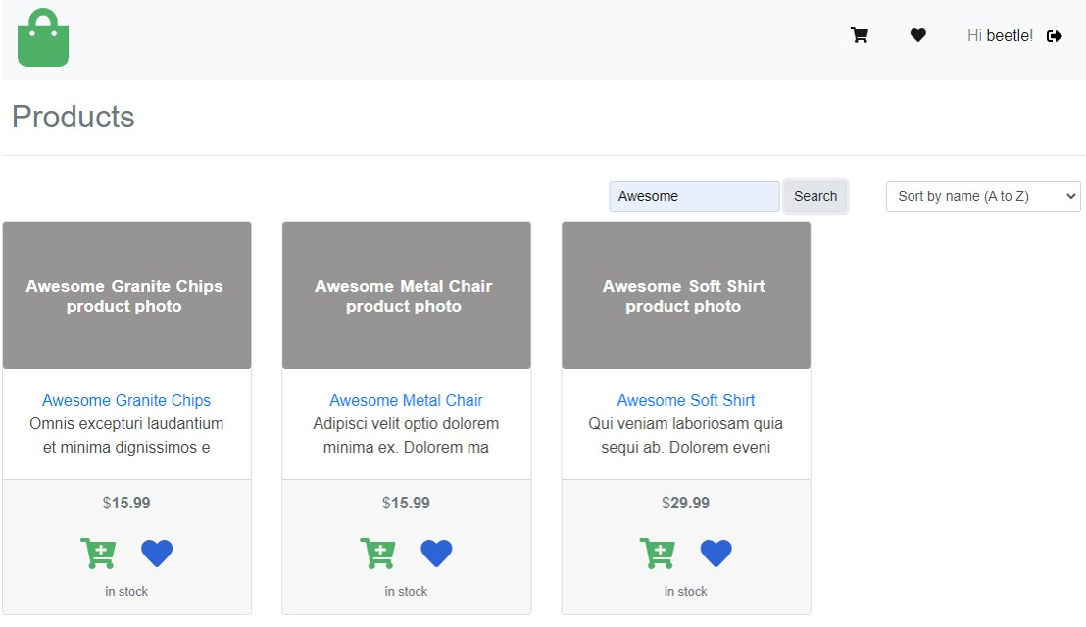

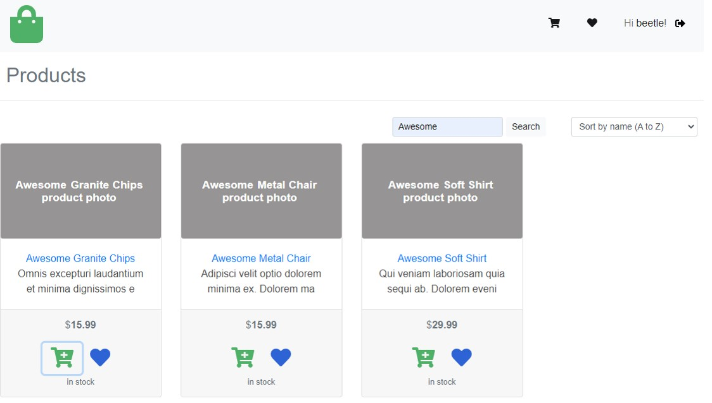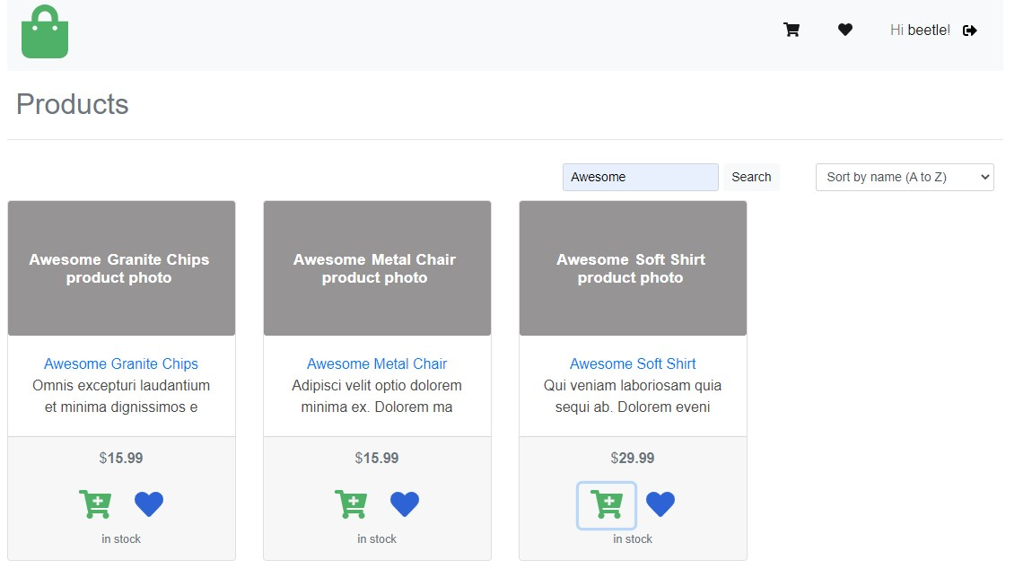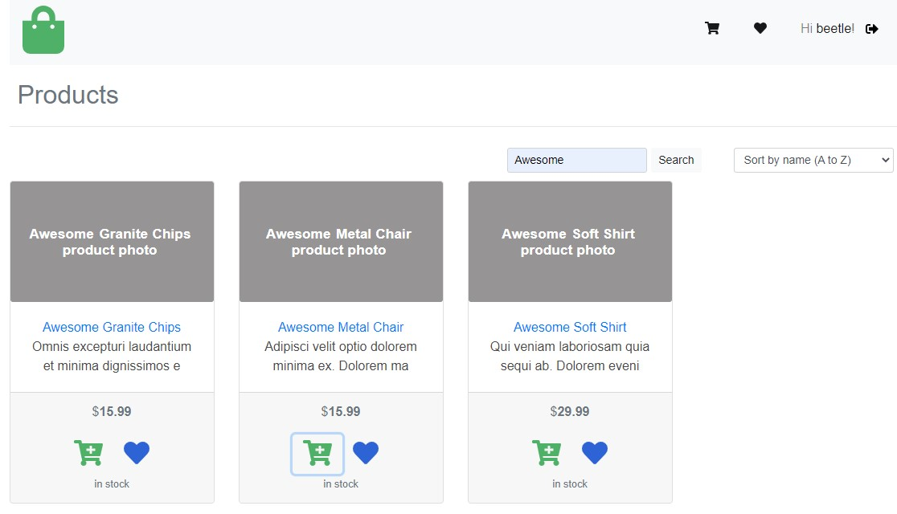



Bug ID : YC-3 (Your cart page )

Bug Title/Summary : Add to cart function of previously added to wish list product not performing

Bug DETAILS :

Type : BUG

Status : New

Priority : High

Severity : High

Environment : Device LAPTOP ; OS WINDOWS ; Browser Google CHROME ; Website <https://fasttrackit-test.netlify.app/#/> ; Version [Demo Shop | build date 2021-05-21 14:04:30 GTBDT](https://fasttrackit-test.netlify.app/) ; Component My Cart

Bug reproduction data : username : beetle password : choochoo

Bug description : After product is first added to wish list and the products green cart symbol is clicked , the black cart symbol does not count the products being added to “Your cart” and product not appear as being added in “Your cart” page

Bug steps to reproduce :

1. Open <https://fasttrackit-test.netlify.app/#/> application website

2. Click black arrow ->] symbol   
  
3. Type in valid username and password   
  
4. Click on blue Login button

5. Click “Awesome Granite Chips” product , “Awesome Metal Chair” product , “Awesome Soft Shirt” product , “Gorgeous Soft Pizza” product blue heart symbol

6. Verify black heart count four products added to wish list

7. Click black heart symbol

8. Verify if related products are added to wish list

9. Click “Awesome Granite Chips” product , “Awesome Metal Chair” product , “Awesome Soft Shirt” product , “Gorgeous Soft Pizza” product green cart symbol

10. Verify black cart symbol count four products added to my cart

11. Click on black cart symbol

12. Verify if products appear added to my cart

Expected results : After click on add to cart function of products previously added to wish list , the black cart symbol should count the quantity of added products to cart and the products should appear as being added to “Your cart” section

Actual results : After products are previously added to wish list and products green cart symbol is clicked the black cart symbol does not count the quantity of added products to cart and “Your cart” section does not show the products as being added to cart . “Your cart” section show “How about adding some products in your cart?” message.

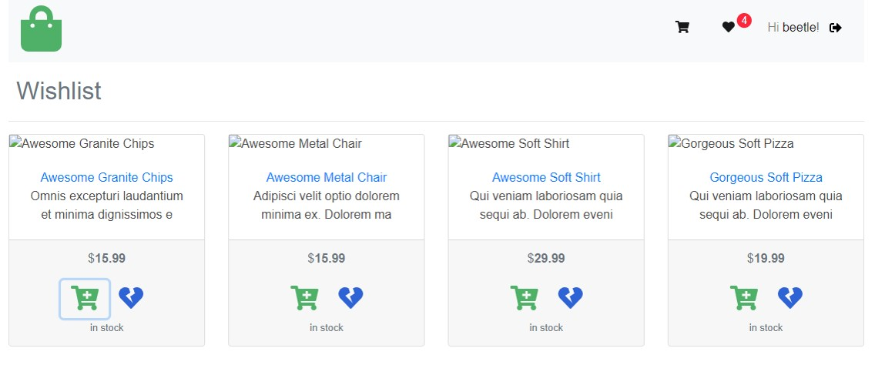

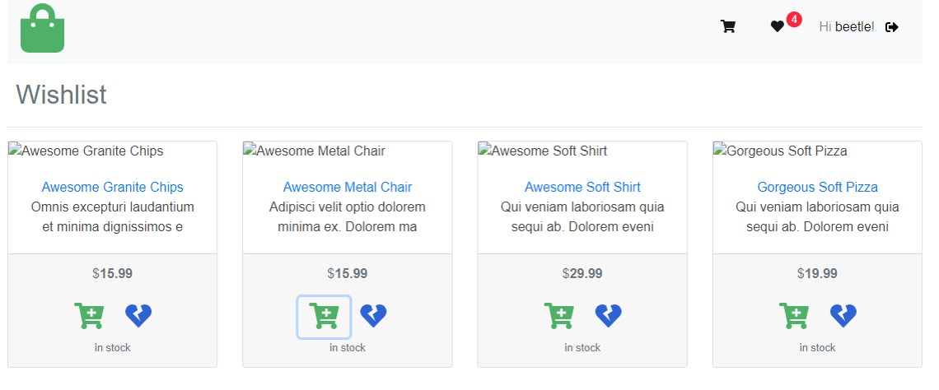

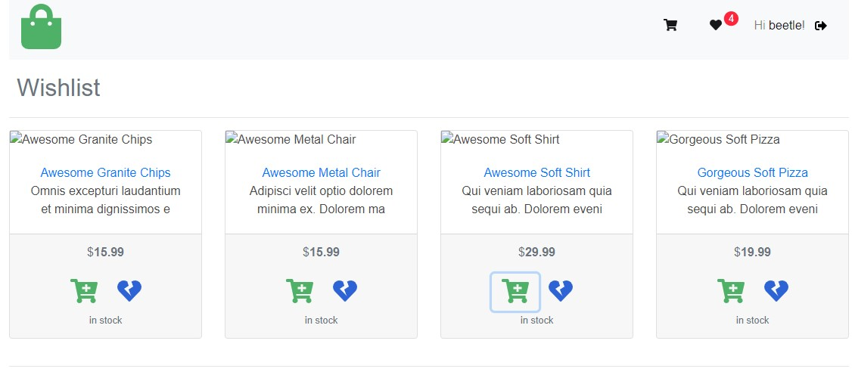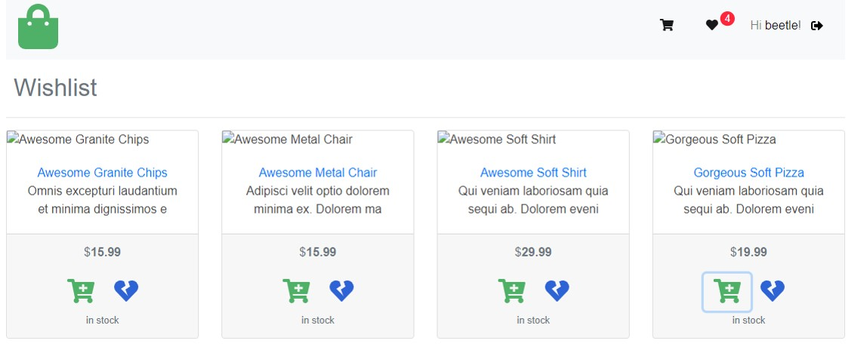

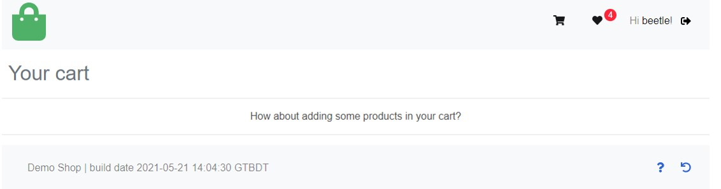

Bug ID : YC-4 (Your cart page )

Bug Title/Summary : Your cart calculate incorrect total value of added products to cart

Bug DETAILS :

Type : BUG

Status : New

Priority : High

Severity : High

Environment : Device LAPTOP ; OS WINDOWS ; Browser Google CHROME ; Website <https://fasttrackit-test.netlify.app/#/> ; Version [Demo Shop | build date 2021-05-21 14:04:30 GTBDT](https://fasttrackit-test.netlify.app/) ; Component My Cart

Bug reproduction data : username : beetle password : choochoo

Bug description : After products are added to your cart section the total value calculation of added products to the cart is calculated wrong

Bug steps to reproduce :

1. Open <https://fasttrackit-test.netlify.app/#/> application website

2. Click black arrow ->] symbol   
  
3. Type in valid username and password   
  
4. Click on blue Login button

5. Click “Incredible Concrete Hat” product, “Practical Wooden Bacon” product, “Licensed Steel Gloves” product green cart symbol

6. Click on black cart symbol

7. Calculate total value of “Incredible Concrete Hat” product price of 7.99$ , “Practical Wooden Bacon” product price of 29.99$ , “Licensed Steel Gloves” product price of 14.99

8. Verify if added products calculated total value by your cart of “Total: 7.99” is equal to products calculated total value by tester of “Total: 52.97”

Expected results : “Total :” value of added products to the cart should be calculated by addition of all the products values added to the your cart , should be calculated mathematically correct

Actual results : “Total :” value of products added to your cart is calculated based only on the products with value of 7.99$ . All added products correct value of 52.97$ is not equal to your cart calculation result of 7.99$

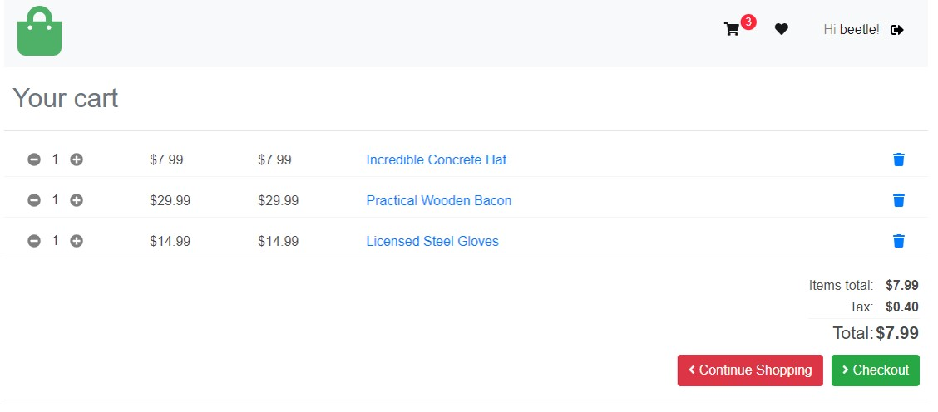

Bug ID : YC-5 (Your cart page )

Bug Title/Summary : Your cart calculate incorrect total value of added products after items quantity is increased

Bug DETAILS :

Type : BUG

Status : New

Priority : High

Severity : High

Environment : Device LAPTOP ; OS WINDOWS ; Browser Google CHROME ; Website <https://fasttrackit-test.netlify.app/#/> ; Version [Demo Shop | build date 2021-05-21 14:04:30 GTBDT](https://fasttrackit-test.netlify.app/) ; Component My Cart

Bug steps to reproduce :

1. Open <https://fasttrackit-test.netlify.app/#/> application website

2. Click black arrow ->] symbol   
  
3. Type in valid username and password   
  
4. Click on blue Login button

5. Click “Practical Wooden Bacon” for $1.99 , “Refined Frozen Mouse” for $9.99 , “Licensed Steel Gloves” for $14.99 products green cart symbol

6. Click on black cart symbol

7. Verify number of items of each product is 1 unit and verify added products total value is $9.99

8. Increase each product items number with 1 unit by click on + button

9. Verify the added products total value update

Expected results : Your cart should update the total value of added products according the increase of the number of items .

Actual results : Your cart does not update the total value of increased product items mathematically correct . Total value after item quantity increase is $19.98 while the correct value it is $53.94

